**How to download my media from Github**

Step 1: Click the <> Code button, Download ZIP file, 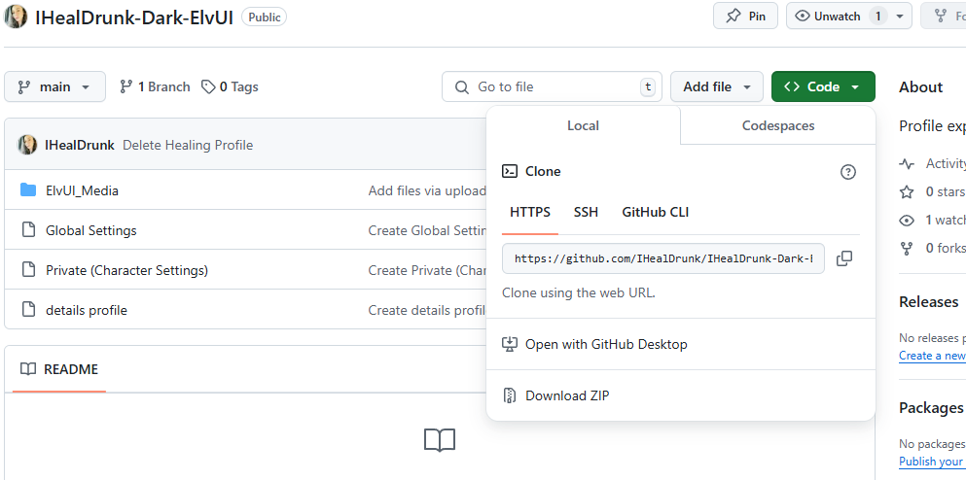

Step 2: Navigate to the zip file and go inside.

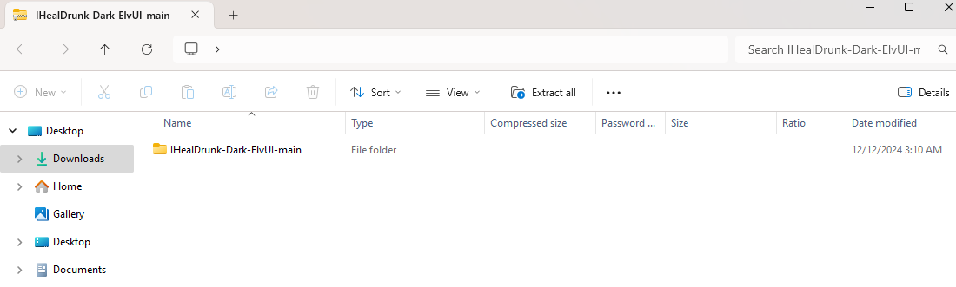

Step 3: Inside the zip file, Select “ElvUI_Media”

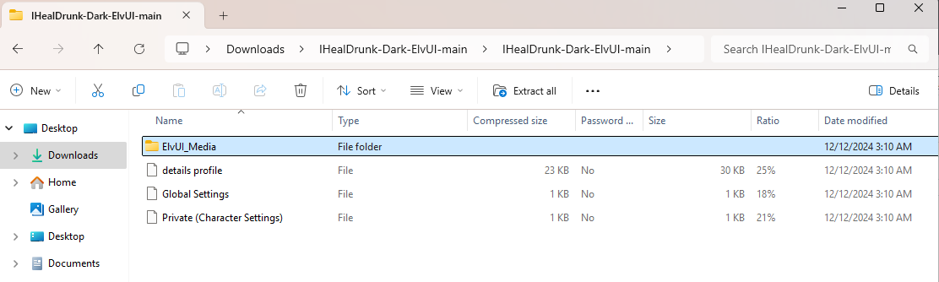

Step 4: Move “ElvUI_Media” into your AddOns folder. *(C:\Program Files (x86)\World of Warcraft\_retail_\Interface\AddOns)*

